**Project Plan – Sortie Logger**

**Zachary Hager, Charles Kimmel, and Matthew White**

**Section 6381**

**Group 4**

**30 September 2022**

**Revision History**

|  |  |  |
| --- | --- | --- |
| **Name** | **Date** | **Description** |
| Zachary Hager | 8/22/2022 | Initial GUI with drop downs and text boxes |
|  |  |  |
|  |  |  |
|  |  |  |
|  |  |  |
|  |  |  |
|  |  |  |
|  |  |  |

**Minimum Hardware System Requirements**

RAM: 256 MB

Disk space: 256 MB Total: (124 MB for JRE; 2 MB for Java Update, *tentative* 128 MB for program)

Processor: Minimum Pentium 2 266 MHz processor

Browsers: Internet Explorer 9 and above, Microsoft Edge, Firefox, Chrome

**Development Platform**

Since our program will be create in Java our team is utilizing the Eclipse and IntelliJ IDEA IDE to write our program. Each of us is utilizing the Java SE 8 JDK or newer to maximize compatibility, and because of its long-term support.

**Basic Functionality**

1. Some sort of GUI for user to input:

a. Aircraft (dropdown)

b. Scheduled Time (text box)

c. Actual Takeoff time (same as scheduled time)

2. Warning (pop up) for a time that is outside of 30 minutes from scheduled time

3. Storage solution

a. Write and save a file

b. Write to a database

-Upgrades (in no particular order)-

1. Aesthetics

2. Database security

3. Cloud options

**UML Diagram**

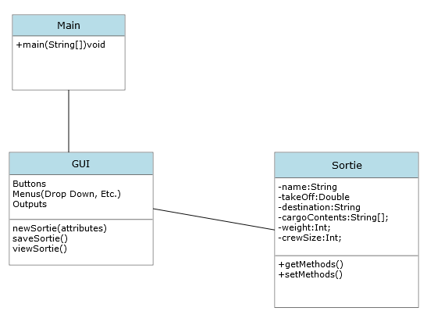

**Software Management**

**GitHub**: Used to share program files, and documentation

**Discord**: For communication and team meetings.

**IntelliJ IDEA & Eclipse:** IDE used between team members.

**Project Schedule**

**Note:** Tasking and timelines subject to change. This schedule is based on week-to-week deliverables.

|  |  |  |  |  |
| --- | --- | --- | --- | --- |
| **Task** | **Duration** | **Start Date** | **End Date** | **Personnel** |
| **Plans and Specifications**  a. Set-up team communication channels  b. Set-up program Classes  c. Team Submissions/answer comments | 1 Week | 8/24/2022 | 8/30/2022 | Zach, Chuck, Matt |
| **User’s Guide and Test Plan**  a. Set-up user guide  b. Create and execute test data files (within application)  c. Team Submissions/answer comments | 1 Week | 8/31/2022 | 9/6/2022 | Zach, Chuck, Matt |
| **Design**  a. Solidify, classes, methods, fields, and interfaces  b. Experiment/migrate to online data base.  c. Team Submissions/answer comments | 1 Week | 9/7/2022 | 9/13/2022 | Zach, Chuck, Matt |
| **Phase I**  a. Working program/performs properly with expected input  b. Hard Goal-Data storage within program/Soft Goal-Data storage in data base  c. Evaluate where we need to change design  d. Team Submissions/answer comments | 1 Week | 9/14/2022 | 9/20/2022 | Zach, Chuck, Matt |
| **Phase II**  a. Robust exception handling and error catching  b. Working data base  c. Evaluate where we need to change design  d. Team Submissions/answer comments | 1 Week | 9/21/2022 | 9/27/2022 | Zach, Chuck, Matt |
| **Phase III**  a. Full Beta of program  b. Evaluate where we need to change design & commit to those changes  c. Team Submissions/answer comments | 1 Week | 9/28/2022 | 10/4/2022 | Zach, Chuck, Matt |
| **Final**  a. Compile all documentation for final report  b. Review final version of program  c. Assess goals meet and limitations  d. Submit final program | 1 Week | 10/5/2022 | 10/11/2022 | Zach, Chuck, Matt |